First Presbyterian Church, Medford

**Sunday, April 27, 2025**

**4:00 PM**

CLASSICAL VESPERS

**JONAS NORDWALL**

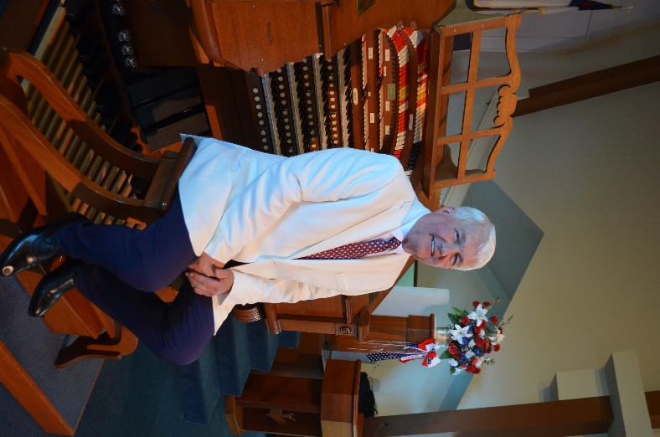

**JONAS NORDWALL**

**ORGANIST**

Jonas Nordwall is a virtuoso organist equally skilled in both traditional classical and modern/popular schools of musical performance. For over a half century he has toured the world presenting concerts in churches and performing arts centers. He has performed in Japan, Europe, China and has made several tours of Australia. In 1999, he was both an adjudicator and recitalist for the Swiss International Organ Competition in Geneva, Switzerland.

Nordwall has over 25 highly acclaimed recordings on a variety of labels. His recordings are frequently heard on the internationally syndicated radio show, “Pipedreams”. He is the only American organist to play a solo concert at the famed Sydney Town Hall for an audience over 2,000, which was also broadcast throughout the South Pacific by the Australian Broadcasting Company. His national television broadcasts include NBC’s “Today Show” and the ABC’s “Good Morning Australia”

A Portland, Oregon native, Nordwall’s first musical studies began at age 4 on the accordion. Besides Portland teachers Joe Parente and Eileen Hagen, he tutored with Charles Magnante and Anthony Galla-Rini. At the age of 16, Nordwall performed for King Gustav Adolf during a tour of Sweden.

His studies expanded to piano and organ at age 10 with Portland teacher, Goldie Pos. Nordwall graduated with a Bachelor of Music Degree from the University of Portland, where his piano, organ and orchestration studies were with Arthur Hitchcock. Additional classical organ studies were with three of the twentieth century’s finest organists - Frederick Geoghegan, the English/Canadian virtuoso, Richard Ellsasser, the American virtuoso and Richard Purvis, the eminent organist-composer of San Francisco’s Grace Cathedral.

Nordwall has been a professional church musician since high school. He has served as the organist for Portland’s First United Methodist Church since 1971 and is presently the Artistic Director of Music. There he oversees one of the finest traditional music ministries in the United States. He has played for many international church gatherings, been an accompanist for the American Choral Directors Association conventions, and performed for several regional conventions of the American Guild of Organists.

As the organist for the Oregon Symphony Orchestra during the tenure of Maestro James DePriest, Nordwall was a featured soloist for several concerts and has recorded with the orchestra on the Delos label. Other orchestral appearances include the Vancouver, BC Symphony Orchestra, Portland Festival and Chamber Orchestras, Columbia Symphony Orchestra, Vancouver, Washington, Symphony Orchestra, San Jose Symphony Orchestra, Peter Britt Music Festival, Cascade Music Festival (Bend, OR) and the Whatcom Symphony Orchestra (Bellingham, WA).

Nordwall is among the most respected theatre organists. During college he had the rare opportunity to be the organist at the Paramount and Oriental Theaters in Portland. For many years he was the Senior Staff Organist for the legendary Organ Grinder Corporation, which had large Wurlitzer pipe organs in lavish restaurant locations in Portland and Denver. In 1987 the American Theatre Organ Society named him Organist of the Year and was inducted into their Hall of Fame in 2022. He directs the ATOS Summer Youth Adventure, the ATOS version of the AGO POE young organist program.

In addition to his musical performances, Nordwall has been a major influence in the later 20th century design and manufacturing of both pipe and electronic organs. He was associated with the Rodgers Organ Company for over 30 years and is an artist for the Allen organ Company. He introduced the MIDI implementation to the organ in 1987 at the National Association of Music Merchants Trade Show in Chicago.

His performances and recordings have received rave reviews, stimulating a new interest in the organ. A recent review stated ” . . . if more organ concerts were as carefully programmed and excellently performed, the organ would again be at the fore-front of the musical public.”