FIRST PRESBYTERIAN CHURCH, MEDFORD

**Sunday, April 13, 2025**

**5:00 PM**

**JAZZ VESPERS**

**Dean Angermeier Band**

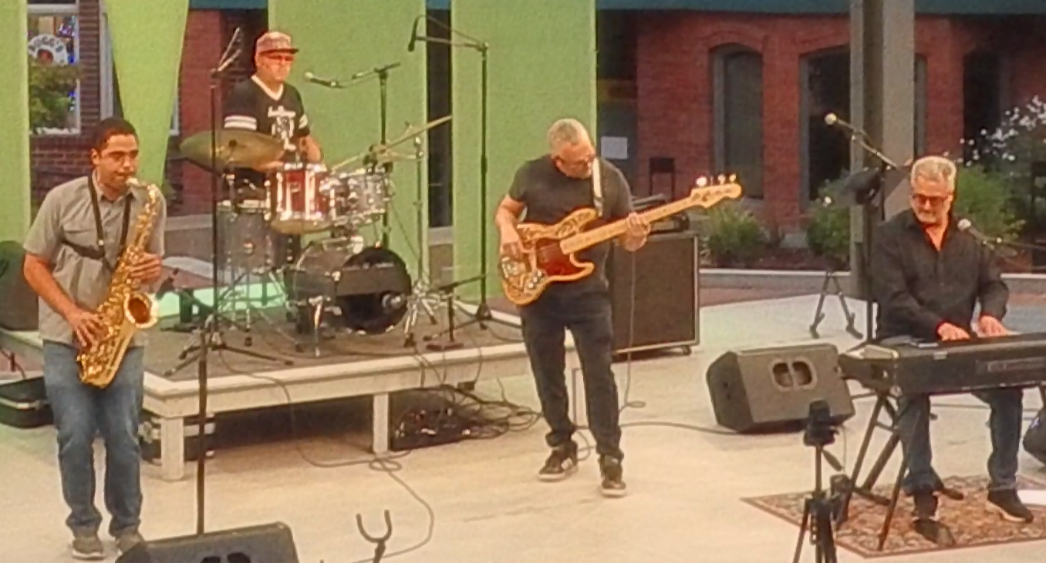

**PROGRAM**

**Opening Music Dean Angermeier Band**

**Welcome & Reading Mike Hubbard**

**Music Dean Angermeier Band**

**Meditation Mike Hubbard**

**Art Notes**

**Closing Mike Hubbard**

**Music to Go Home By Dean Angermeier Band**

**Thank you, Friends, for the generous freewill offerings**

**that you put in the entrance basket in order to keep our**

**Jazz Vespers program going.**

**Our Guest Musicians this Month are:**

**Dean Angermeier** is a versatile pianist and keyboardist known for his dynamic presence in the Rogue Valley music scene. Growing up in a musical household, he developed a deep appreciation for a wide range of styles, from jazz and rock to fusion and blues. He honed his craft at the University of Michigan’s renowned jazz program, where he refined his improvisational skills and harmonic sophistication. Now an in-demand musician, Dean leads and collaborates on multiple projects, including his original jazz group and genre-spanning performances with top-tier regional artists. Whether reinterpreting Steely Dan, exploring the improvisational depths of the Grateful Dead, or crafting his own compositions, Dean’s ability to adapt and elevate any musical setting makes him a standout musician in the Rogue Valley.

## Tarik Ragab is a multi-instrumentalist and songwriter living and working between Ashland, OR and the San Francisco Bay Area. Raze The Maze is Tarik's original prog-pop band with musical collaborator and wife, Moorea Dickason.  While Tarik plays bass and composes for Raze The Maze, he also plays guitar and piano, and teaches private lessons in all 3 instruments + composition. Tarik is also a giggin, working musician in many bands playing jazz, rock, funk, and Latin-fusion. Before Raze The Maze, Tarik was the co-founder of the critically acclaimed progressive rock band, MoeTar, and the Latin fusion band, Machina Sol.  He has arranged music for Oakland Symphony and performed at Fox Theater, SF Jazz, CBGB, Verizon Amphitheater, and hundreds of clubs across the US.

**Adam Harris** is an Oregon-based jazz saxophonist, composer and music educator. Over the last decade, he has established a reputation for himself as a powerful voice in the Pacific Northwest music scene. In 2006, he graduated with a Bachelor of Music degree from Cornish College of the Arts in Seattle, where he studied with many of the area's most well known jazz musicians including legendary trombonist Julian Priester, Jovino Santos Neto, Jay Thomas and Jim Knapp.  
In 2011, Adam graduated from the New England Conservatory of Music in Boston, where he earned a Master of Music degree. While in Boston, he studied with many critically acclaimed artists including Donny McCaslin, Miguel Zenon, Jerry Bergonzi, George Garzone, Billy Hart and Cecil McBee. His first album as a leader, “The Adam Harris Quintet - Live at the Jazz Station”, was released in 2014 and features the internationally celebrated pianist George Colligan. In 2015, Adam received a Master of Arts in Teaching degree at Western Oregon University and proceeded to teach music at the middle and high school level in Washington state.  
From 2022-2024, he was the Director of Jazz Education and Saxophone Professor at Western Oregon University in Monmouth, Oregon.  
In 2024, he accepted a full-time teaching position at Ashland High School in Ashland, Oregon.  
In addition to maintaining a busy teaching schedule, Adam also performs professionally on a regular basis throughout the west coast. Over the past several years, he has shared the stage with some of the world's most famous jazz musicians, including Wynton Marsalis, Dave Holland, Randy Brecker and Joshua Redman.

**Eric Pollard** is a multi-instrumentalist/composer/vocalist who performs under the pseudonym Actual Wolf.

He has performed in many notable groups such as LOW, SunKilMoon, Trampled by Turtles & Nikki Lane… amongst many others.

He is an active member of Actual Wolf, Dean’s FunTime Party Band, Eptás & The Danielle Kelly Soul Project.

It is his dream to someday be recognized financially for his contributions to art but he is not hopeful. This is the main driver of his creative vision & his overall recklessness. He is ideally a high concept guy inhabiting the working class body of a redneck from Northern Minnesota. He definitely appreciates you.