FIRST PRESBYTERIAN CHURCH, MEDFORD

**Sunday, October 13, 2024**

**5:00 PM**

**JAZZ VESPERS**

**Peter Anastos Quartet**

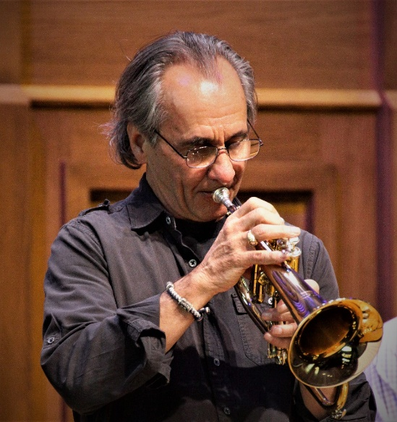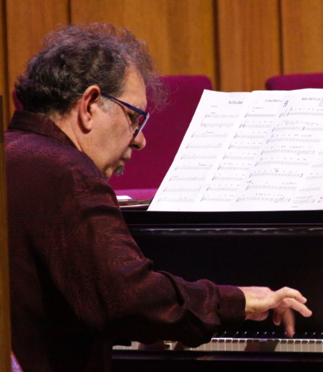

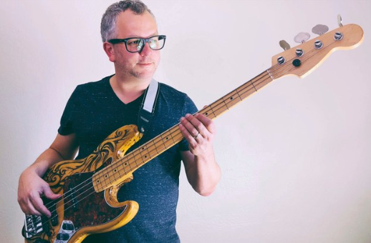

**Paintings by Cheryl Magellen**

**PROGRAM**

**Opening Music Peter Anastos Quartet**

**Welcome and Readings Murray Richmond**

**Music Peter Anastos Quartet**

**Meditation Murray Richmond**

**Art Notes Cheryl Magellen**

**Closing and Benediction Murray Richmond**

**Music to Go Home By Peter Anastos Quartet**

**__________________________________________________________________**

**Thank you, Friends, for the generous freewill offerings**

**that you put in the entrance basket in order to keep our**

**Jazz Vespers program going.**

**Our Guest Musicians this Month are:**

**Peter Anastos -** trumpet

**Peter Anastos** is a trumpeter, composer, and arranger. He has many original compositions to his credit. In 2005 he formed his own group in the Bay Area, *Peter Anastos & Iter*, which features his original work. and has since produced two albums. Peter has recorded three cds as a leader, the last one, “Sempiternity”, being released in 2022. Over time he incorporated the influences of his Greek heritage into the music and added a bouzouki to the instrumentation which allowed the band to expand its experimental horizons beyond that of the hard bop originals. Peter has also written arrangements for big bands, including the big band at the Jazz Conservatory in Berkeley, CA. Peter has played with such notables as Karrin Allyson, Steve Erquiaga, and Frank Martin. He currently plays with his own small ensembles around the southern Rogue Valley. Peter and his wife, Angela Koregelos, moved to Ashland in 2018.

**John Mazzei -** piano

**John** lived in the Rogue Valley from 1983-1993 and was hot on the local jazz scene as well as production artist for many west coast musicians. You may have heard him play at the Marc Anthony in Ashland and at many other local venues during this time. Since 2007 he has been writing music for several publishers worldwide providing music for film and TV. He currently has music on over 275 TV shows and counting. In 2018 John retired from his job of 22 years at Genentech and they returned to the Rogue Valley, settling in Jacksonville

**Tarik Ragab** - bass

**Tarik Ragab** is a multi-instrumentalist and songwriter living and working between Ashland, OR and the San Francisco Bay Area. Raze The Maze is Tarik's original prog-pop band with musical collaborator and wife, MooreaDickason.While Tarik plays bass and composes for Raze The Maze, he also plays guitar and piano, and teaches private lessons in all 3 instruments + composition. Tarik is also a giggin, working musician in many bands playing jazz, rock, funk, and Latin-fusion. Before Raze The Maze, Tarik was the co-founder of the critically acclaimed progressive rock band, MoeTar, and the Latin fusion band, Machina Sol. He has arranged music for Oakland Symphony and performed at Fox Theater, SF Jazz, CBGB, Verizon Amphitheater, and hundreds of clubs across the US.. 

**Eric Pollard -** drums

**Eric Pollard** is a recent transplant to the Rogue Valley but has quickly established himself as one of the most sought after musicians in the area. As a drummer and multi-instrumentalist, he has toured the world with acts like LOW, Retribution Gospel Choir, Sun Kil Moon, Nikki Lane, HALEY & JP Harris among many others. He is also the driving creative force behind the rock and roll band, Actual Wolf.

**_______________________________**

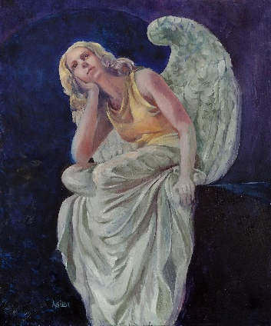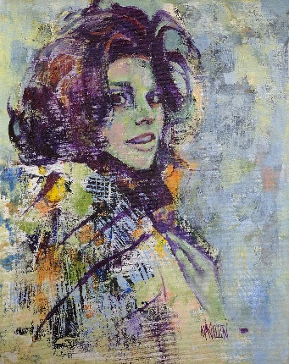 **Paintings by Cheryl Magellen**

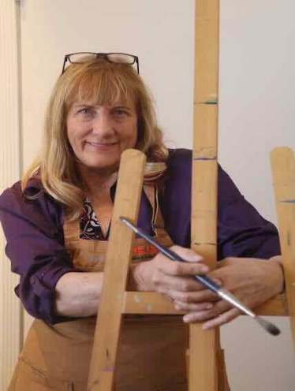

Cheryl began her love affair with drawing by copying the faces of pop star personalities from magazines as a teenager. Carrying that love affair through high school, she went on to receive a BA degree from Chico State University, studied drawing at the Southern Oregon Art Academy, and painting at the Scottsdale Artists’ School.

Although Cheryl paints many different subjects, her love of portraits and figures comes through in her flare for various character types and moods. The strength of her work is found in her loose, impressionistic style, and expressive brushwork. She chooses to paint her subjects with bright color, projecting a positive experience for the viewer. Her paintings are often done with acrylic under-painting, bringing out special detailing with oil and line. Her award-winning art has been featured in several print and International exhibitions. She teaches locally and also offers classes online.

**Coming Next Month:**

**JAZZ VESPERS**

**November 10, 2024 Mark Hamersly Quintet**

**Special Thanks to:**

**Rev. Murray Richmond**

**Robin Blomquist- Coordinator of Jazz and Classical Vespers**

**Peter Anastos, John Mazzei, Tarik Ragab, Eric Pollard** **- Musicians**

**Cheryl Magellen– Artist**

**Robin Blomquist – video**

**Ginni & Dudley Peterson, Jane Blomquist - greeters**

**Paulette Avery, Tam Moore, Elizbeth Mahan – publicity**

**Tom McDermott – sound and lights**

**Ted Killian, Robin Blomquist – art installations**

**And the wonderful members of**

**First Presbyterian Church, Medford**

**and you, the community participants,**

**for supporting this endeavor.**

**First Presbyterian Church**

**85 South Holly, Medford, Oregon 97501**

**541 779-1711 – FPCM@firstpresmedford.com**